Meeting Minutes



## Meeting date | time 19/02/18 | 9:30 | Meeting location 201

|  |  |  |  |  |  |  |  |  |  |  |  |
| --- | --- | --- | --- | --- | --- | --- | --- | --- | --- | --- | --- |
| |  |  | | --- | --- | | Meeting called by | Sean Breen | | Type of meeting | Forward Planning | | Lead | Sean Brean | | Note taker | Sara Pattinson | | Timekeeper | Kieran Plank | | Marcin Olesiak |

# Agenda topics

## Time allotted | 30 minutes | Agenda topic Review of Last Actions | Presenter Sean

Derek has confirmed that we can develop for chrome and do not need to consider IE development.

Syllabus choice is for Web Development unit for Higher, progressing to advanced higher if there is time.

All members have created their own database design.

Gantt chart and meeting notes have all been added to Git.

## Time allotted | 20 minutes | Agenda topic Gantt Charts | Presenter Sean

Needs further granular decomposition. The team Gantt will be more general but each member will take charge of their own specific tasks and time management which will all be submitted. Gantt should be shaped around site map.

|  |
| --- |
| Action items |
| All need to start their own Gantt |

## Time allotted | 20 minutes | Agenda topic Role Realignment | Presenter Sean

Sean retains the same roles but has taken position as team leader as Sara has moved to part-time. He will develop the website and control out main GitHub account

Marcin will also focus on web development and project management.

Kieran will test the website and be the authority on the design of the website due to his research project. He will also work on the SQL. He will also make the user-guide.

Sara will also test the website and build SQL. And due to her research project on computational thinking she will create the quizzes and assessments.

This way everyone has technical and non-technical elements.

## Time allotted | 30 minutes | Agenda topic Database Design | Presenter Sara

Some designs were missing key elements and did not consider future potential developments so Kieran and Sara will work on a design and relevant statements that may be needed. Sara and Sean will work together on the analytics that will need pulled for the database to get the student and teacher dashboard areas.

|  |  |  |
| --- | --- | --- |
| Action items | Person responsible | Deadline |
| New Database design | Kieran and Sara | 27/02/2018 |

## Time allotted | 45 minutes | Agenda topic Site Map | Presenter Sara

Discussion was had to hash out the site map:

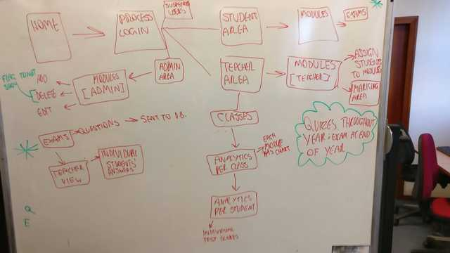

Topics will be confined to HTML, CSS and JS and there will be at least 7 quizzes based on the ADIIITE model of the syllabus. There will be one main assessment at the end of the web development module.